DBMS ASSIGNMENT 1

PIYUSH MISHRA

Q1. What is Data? State difference between Information and Knowledge.

*Data refers to distinct pieces of information, usually formatted and stored in a way that is concordant with a specific purpose. Data can exist in various forms: as numbers or text recorded on paper, as bits or bytes stored in electronic memory, or as facts living in a person’s mind.*

*Information is processed, organised and structured data. It provides context for data and enables decision making processes.*

*Knowledge is facts, information, and skills acquired through experience or education; the theoretical or practical understanding of a subject.*

Q2. Draw ER diagram of Library management system.

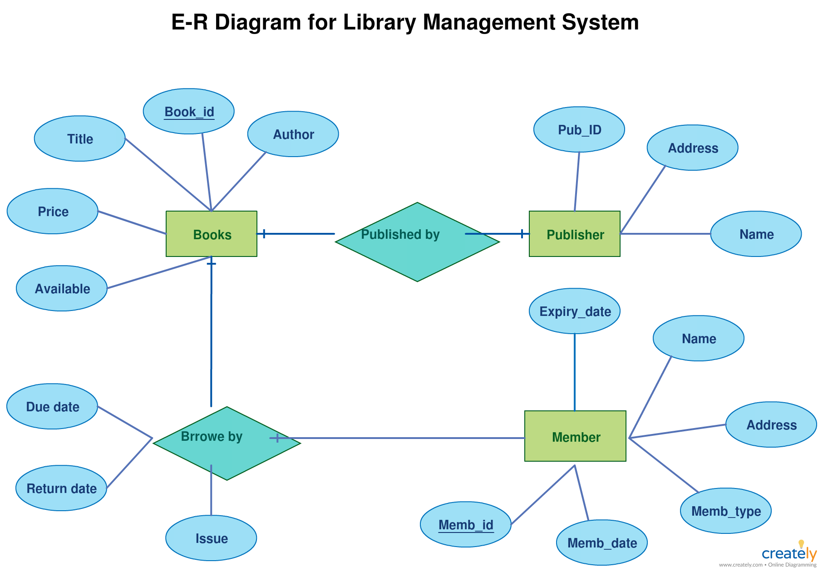

Q3. Create a Table with any 4 constraints.

CREATE TABLE Employee (

EmployeeId Integer PRIMARY KEY

FName Varchar2(20) NOT NULL

LName Varchar2(20) NOT NULL

Gender char(1) CHECK(Gender IN(‘M’,’F’))

ContactNo Number(10) UNIQUE

)

Q4. Given the tables:

Employee (Emp_id, Emp_Name, Salary, Dept_id) Department

(Dept_id, Dept_Name)

Display 10 departments with highest average salary for employees

(along with the average salary).

Select d.Dept_id,avg(salary) From Employee e inner join Department d on e.Dept_id = d.Dept_id

Group by d.Dept_id

Order by avg(salary) desc Limit 10;

Q5. List down any 5 types of Constraints and explain them.

1. NOT NULL

It restricts a column from having a Null value.

You cannot pass a null value to that column.

It is a column level constraint and can’t be defined at table level.

1. UNIQUE

It restricts duplicate values.

All primary keys are unique.

It accepts null value provided should not be a primary key.

Multiple unique constraint can be defined on a table.

1. PRIMARY KEY

It restricts duplicate values.

All primary keys are unique.

It doesn’t accept null values.

Multiple columns can be combined to form a primary key.

Only one primary key can be defined per table.

1. FOREIGN KEY

It prevents invalid data from being inserted into the foreign key column,because it has to be one of the values contained in the parent table.

It maintains a child - parent relationship.

It doesn’t accept null values.

Foreign key is a primary key from the Parent table.

1. CHECK

It is useful when we need to restrict a column to receive certain values.

For example, we can restrict a column named Age to get only positive numbers.

Q6. What are the requirements of Data?

1. Integrity

Integrity means the data should be accurate.

1. Security

Security means the data shouldn’t be available to the ones who don’t have the access to data or have been restricted.

1. Availability

Availability means the data should be available to everyone who has been granted access to it.

1. Concurrency

Concurrency means the data should be available to multiple users at the same time.

1. Independent of Application

Independent of Application means the data should be available to users from multiple devices. For example, the data should be accessible from an ios device, a PC and from laptop at the same time.

Q7. 3-level architecture of DBMS.

1. External Level

External Level is also called the View Level. It is called the View Level because several users can view their desired data from this level which is internally fetched from the database with the help of conceptual and internal level mapping.

1. Conceptual Level

Conceptual Level is also called the Logical Level. It is called the Logical Level because the whole design of the database such as relationship among data,schema of data etc. are described in this level.

1. Internal Level

The Internal Level is also called the Physical Level. It is called the Physical Level because it describes how the data is actually stored in the storage devices and is also responsible for allocating spaces to the data.

Q8. Given the tables:

Employee (Emp_id, Emp_Name, Salary, Dept_id) Department

(Dept_id, Dept_Name), Shift (Shift_id, Shift_type)

Display 10 Departments with maximum employees working the night

shift.

select dept_name, count(employee) from employee e inner join department d on e.Dept_Id=d.dept_Id inner join shift s on s.Dept_id = d.dept_Id where shift='night'

group by department

order by count(employees)

limit 10;